A Comparative Evaluation of Vector, Vectorless, and Graph-Based Agentic RAG Architectures for Enterprise Knowledge Systems

1st Atharva Sawant Department of Artificial Intelligence and Data Science Engineering SIES Graduate School of Technology Navi Mumbai, India satharva2004@gmail.com
2nd Dr Rizwana Shaik Department of Artificial Intelligence and Data Science Engineering SIES Graduate School of Technology Navi Mumbai, India rizwanas@sies.edu.in
3rd Shiney Varghese Department of Artificial Intelligence and Data Science Engineering SIES Graduate School of Technology Navi Mumbai, India shineyv@sies.edu.in
4th Dr Ujawala Ravale Department of Artificial Intelligence and Data Science Engineering SIES Graduate School of Technology Navi Mumbai, India ujwalar@sies.edu.in

Abstract - Enterprise deployments of Large Language Models increasingly rely on Retrieval-Augmented Generation (RAG) to ground responses in organizational knowledge, yet practitioners face a fragmented landscape of retrieval paradigms dense vector search, Vectorless Hierarchical/Lexical retrieval (e.g., PageIndex-style structural reasoning), and graph-based multi-hop retrieval each embedded within Agentic systems that add planning, tool use, and reflection. This heterogeneity is compounded by a lack of standardized agent harnesses and evaluation methodologies, making it difficult to compare systems built on fundamentally different retrieval substrates. This paper surveys how each paradigm is used in Agentic RAG pipelines, examining the role of the agent harness in orchestrating retrieval, tool calls, and multi-step reasoning, and the evaluation challenges specific to Agentic systems. We then present a small controlled evaluation across a common enterprise document set and question categories (factual, semantic/paraphrased, and multi-hop relational), comparing accuracy, latency, and token cost across three prototype implementations. Results indicate paradigm-specific strengths that motivate harness-level routing rather than single-paradigm deployment.
Keywords - Agentic Retrieval-Augmented Generation, Agent Harness, Agent Evaluation, Vector Search, Vectorless Retrieval, Graph RAG, Enterprise Knowledge Systems, Hybrid Retrieval, LLM Benchmarking
- Introduction

Modern companies collect a large amount of different types of information, including reports, presentations, spreadsheets, contracts, and operational records. These documents are often spread across various collaborative platforms like Google Drive, SharePoint, and Dropbox. A mid-
sized company could have tens of thousands of these documents, gathered over many years, with important knowledge stored in different departments, project folders, and personal drives in a way that makes it hard to find systematically. This problem is more than just a hassle; it's a major issue. Industry studies show that knowledge workers spend about 15-25% of their work time searching for or redoing information. Some recent surveys, especially those post-pandemic, suggest this could be as high as half a day or even a full day each week for many employees. Furthermore, enterprise search systems are not very effective, achieving only about a 10% success rate on the first try, compared to consumer web searches, which highlights that the issue isn't a lack of information but an inability to find it within the company's own systems.
The rise of large language models has made conversational AI tools like ChatGPT, Claude, and Gemini the go-to choice for many knowledge-related tasks, such as summarizing, searching, and generating ideas.
However, these tools operate in isolated sessions, meaning insights from one employee aren’t shared with others. The model doesn't remember past interactions or understand the organization's history or ongoing projects. Plus, sending sensitive company data to external providers raises concerns about data privacy and where the data is stored. This results in the same questions being asked repeatedly by different employees with no memory of previous answers. General-purpose models also aren't fine-tuned to an organization's specific terminology, access controls, or industry practices.
Retrieval-Augmented Generation (RAG) has become the main approach to address this problem.
Instead of relying only on the model's internal knowledge, these systems use retrieved documents to ground their outputs, reducing the need for expensive fine-tuning. However, the term "RAG" covers a wide

XXX-X-XXXX-XXXX-X/XX/$XX.00 ©20XX IEEE

range of different architectures that are becoming increasingly complex and fragmented. While dense vector retrieval over embedding indices is still the standard, it's often supplemented or replaced by other methods. These include vectorless approaches that use large language models to perform structured reasoning over a document's hierarchy, similar to how a human reads a table of contents, and graph-based methods that represent organizational knowledge as entities and relationships to support multi-step reasoning across documents. Each of these approaches was developed to address specific weaknesses of previous methods. For example, embedding an entire document as a single vector can reduce the specificity of retrieval, making it hard to find exact matches or detailed technical information, which has led to the development of both hybrid dense-sparse retrieval and more structure-aware alternatives.
This fragmentation is further compounded by the increasing complexity of enterprise RAG systems.
Modern deployments are no longer just simple retrieve-then-generate pipelines. They are now often agentic, involving an orchestration layer, or agent harness, which manages planning, tool invocation, multi-step retrieval, and reflection on intermediate steps before generating a final answer. This shift introduces another axis of fragmentation: the design of the agent harness that wraps the retrieval system. One of the critical issues is that most existing agent benchmarks don't clearly separate the evaluation of the underlying large language model's capabilities from the design of the agent harness or its surrounding structure. This makes it difficult to determine whether differences in performance are due to the retrieval method, the harness design, or the base model itself.
This paper directly addresses this fragmentation. Instead of proposing a single best architecture, it (i) explores how different retrieval methods vector, vectorless, and graph-based are used in agentic RAG systems and how the agent harness plays a role in each, (ii) examines how agent evaluation differs from regular retrieval evaluation, and (iii) presents a controlled comparison across a common set of enterprise documents and questions, measuring accuracy, response time, and cost in terms of tokens for each approach. The goal is not to declare a single winner but to understand where each method fits best, helping practitioners make informed decisions for their enterprise RAG systems

- Agentic RAG: Harness and Evaluation Backgroune

The Agent Harness
A basic large language model, when given a prompt, creates one text response and then stops. It
doesn't remember previous steps, can't use outside tools on its own, and doesn't know when to stop thinking and give an answer. The model can say it wants to use a tool, but it needs something else to actually make that happen. This something else is called the agent harness. The harness is the software around the LLM that turns it into a system that can take multiple steps, use tools, and correct itself. It includes everything that wraps the LLM, like the loop that manages the process, the tools, memory, the way context is handled, saving state, error handling, and safety checks.
In the case of enterprise RAG, the harness is what decides for a user's question whether to do a search, which index or tool to use, if the information found is enough, or if more searching is needed, and when to stop and give the final answer. This term has become common in describing the structure that turns the raw model into a dependable agent.
In the case of RAG systems, the common actions the harness uses are: (1) searching a retrieval index, which could be vector-based, non-vector, or graph-based; (2) calling an external API or accessing structured data; and (3) delivering a final answer with references. This is important for comparing different systems because the way retrieval is done and the way the harness works are two separate choices. The same loop can be used with different types of retrieval tools, like a vector index, a hierarchical document structure, or a knowledge graph.
What changes is the tool used, not the loop itself. Confusing these two, like blaming performance differences on the entire RAG system without separating the retrieval method from how the harness uses it, is a common mistake in informal comparisons. That's why Section II.B treats evaluating the harness separately from the retrieval method.
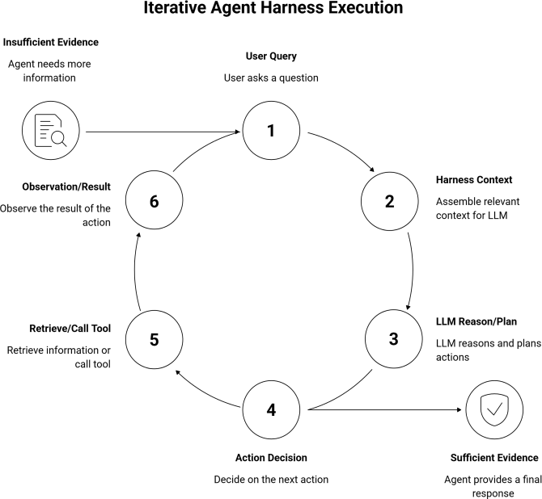

Figure 1. Agent Harness Execution Loop

Evaluating Agentic RAG Systems
Traditional RAG evaluation reduces to a single question: did the system retrieve the right document, and did the generated answer match a reference answer? This formulation is adequate for single-shot retrieve-then-generate pipelines, but agentic systems introduce intermediate decisions whether to retrieve, how many times, which tool, and when to stop that a single end-to-end accuracy score cannot diagnose. We therefore decompose evaluation into per-step binary judgments over the trajectory the agent actually produced, following the capability-decomposition approach used in recent agentic RAG benchmarks that frame evaluation around intermediate capabilities planning, evidence extraction, grounded reasoning, and robustness to noise rather than a single retrieval accuracy number
For each question in our set, we track three binary results. Retrieval correctness (Rq=1) means the system found the right passage needed to answer the question, no matter what the final answer is. Groundedness (Gq=1) checks if the final answer is based on the retrieved information if Gq=0, it means the answer is made up even if the right passage was found, because the model either ignored or disagreed with the correct evidence. Answer correctness (Aq=1) means the final answer matches what is expected for the question.
For a question set of size N, we report each as a simple accuracy:

- Retruveal Accuracy-
type factual, semantic, or relational instead of giving a single overall score, because it's this breakdown that shows exactly where each method struggles.
We also record latency (Lq) and token cost (Cq) for each query, using the cost formula described in Section V. For systems that work with agents, Cq includes all the tokens used during every step like retrieval calls and reasoning not just the final answer. This means multi-step retrieval can increase the cost compared to single-step methods, even if the final answer is the same.
Since our evaluation covers around 15 to 20 questions per method, Rq and Gq were assessed manually by the authors using annotated references for each question.This is practical for small-scale work, but it doesn't match the typical approach in large evaluations where LLMs are used as judges, which we discuss again in Section VII.

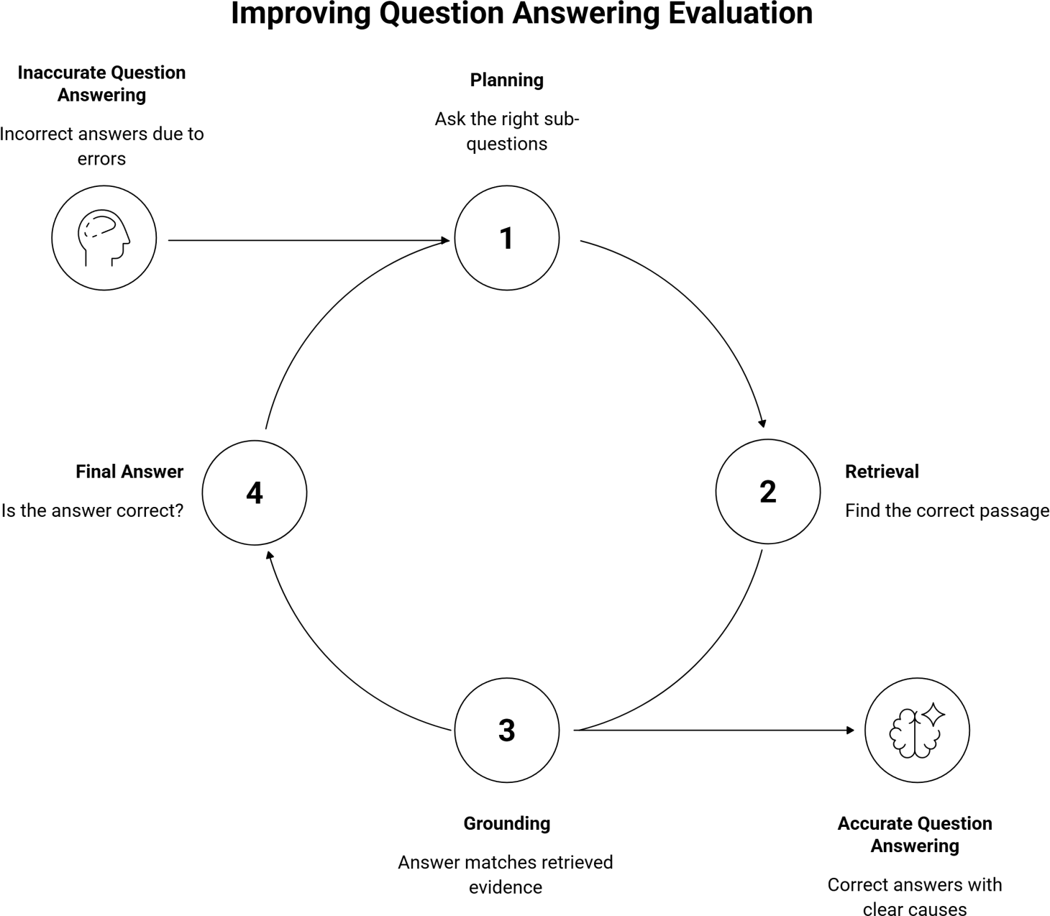
1 N

RetrievalAccuracy= ∑ R_{q}
N
q=1

- Groundedness-
1 N
Groundedness=
Figure 2. Evaluation Breakdown per Question
- RAG Paradigms in Practice
Within an agentic harness, the retrieval step described in Section II.A can be implemented

- Answer Accuracy-
∑ G_{q}
q=1
N
through fundamentally different mechanisms. This section surveys three such paradigms dense vector retrieval, vectorless hierarchical retrieval, and graph-based retrieval describing how each represents knowledge, how it is queried, and the class of

1 N
AnswerAccuracy= ∑ A_{q}
N
q=1

These three numbers help us identify where errors happen in a specific stage: a low retrieval accuracy shows a problem with the retrieval process itself, while high retrieval accuracy but low groundedness points to an issue in the generation part the system found the right information but didn't use it properly. We break down the results by question
enterprise problems it is best suited to.

Vector RAG
Dense vector retrieval is still the main method used in most RAG systems. When documents are broken into smaller parts, they are turned into high-dimensional embeddings using a semantic model. These embeddings are saved in a vector database and found when a query is made by searching for similar vectors through approximate nearest-neighbor

methods [13]. The most common way to organize these vectors is through Hierarchical Navigable Small World (HNSW). HNSW builds a layered graph of vectors and uses a search process that has logarithmic complexity instead of linear, which makes searches faster but requires more time and memory to build the index [13]. The effectiveness of retrieval in this setup largely depends on how the documents are split into chunks and which embedding model is used. Recursive semantic chunking, which divides documents by structural parts like headers and paragraphs before using sentence-level splits, usually works better than fixed-size chunking because it keeps the meaning and context of each part intact [5].
The main advantage of vector-based RAG is its ability to understand and handle different ways of expressing the same idea. The main drawback is that if a query contains specific terms, product codes, acronyms, or domain-specific terms that the embedding model hasn’t seen before, it might not retrieve the right information. This has led to the use of mixed approaches that combine dense and sparse methods in real-world applications [13]. Vector RAG is especially useful for large, varied, and unstructured collections of documents where questions are often phrased differently, and the cost of setting up and maintaining a vector index and embedding system is worth it given the size of the data.

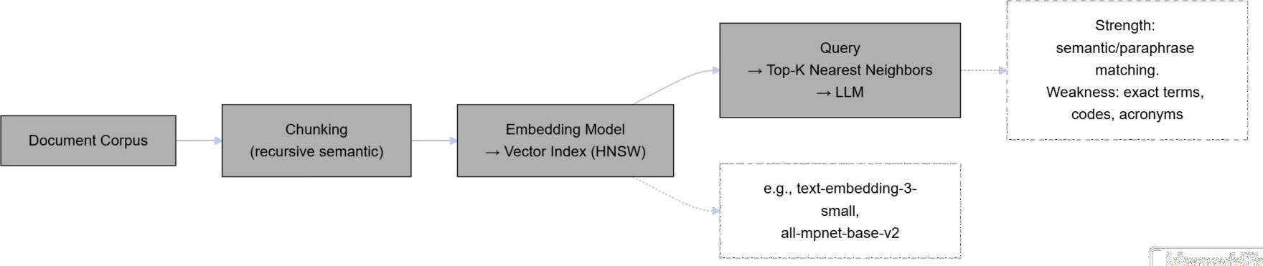

Figure 3. Vector RAG Pipeline

Vectorless RAG
Vectorless retrieval completely skips the embedding-and-vector-index process. Instead, it represents a document as an explicit hierarchical structure an actual tree that reflects how the document is organized, like chapters, sections, and subsections. At query time, an LLM is used to navigate this tree, much like a human would look at a table of contents instead of searching through text for similar content. The retrieval process works like a reasoning task: the LLM is shown the document's structure and asked to determine which parts of the tree are most likely to contain the answer. It then dives deeper into those parts until it finds the specific content.
This approach replaces the upfront costs of generating embeddings and maintaining a vector index with the cost of reasoning during each query. It
also changes how information is matched, moving from semantic similarity to structural and word-based accuracy. This method works especially well with documents that have clear internal organization, like technical manuals, legal contracts, regulatory filings, or long policy documents. In these cases, the answer to aquery is usually found in a specific, identifiable section, and exact traceability to a section is important for record-keeping. Because no embedding model or vector database is required, this paradigm also avoids the data-residency and infrastructure concerns associated with sending document content to external embedding APIs [13]. The main downside is similar to vector RAG: it's not as effective for queries that need to combine information from many different sections or rely on meaning rather than structure.
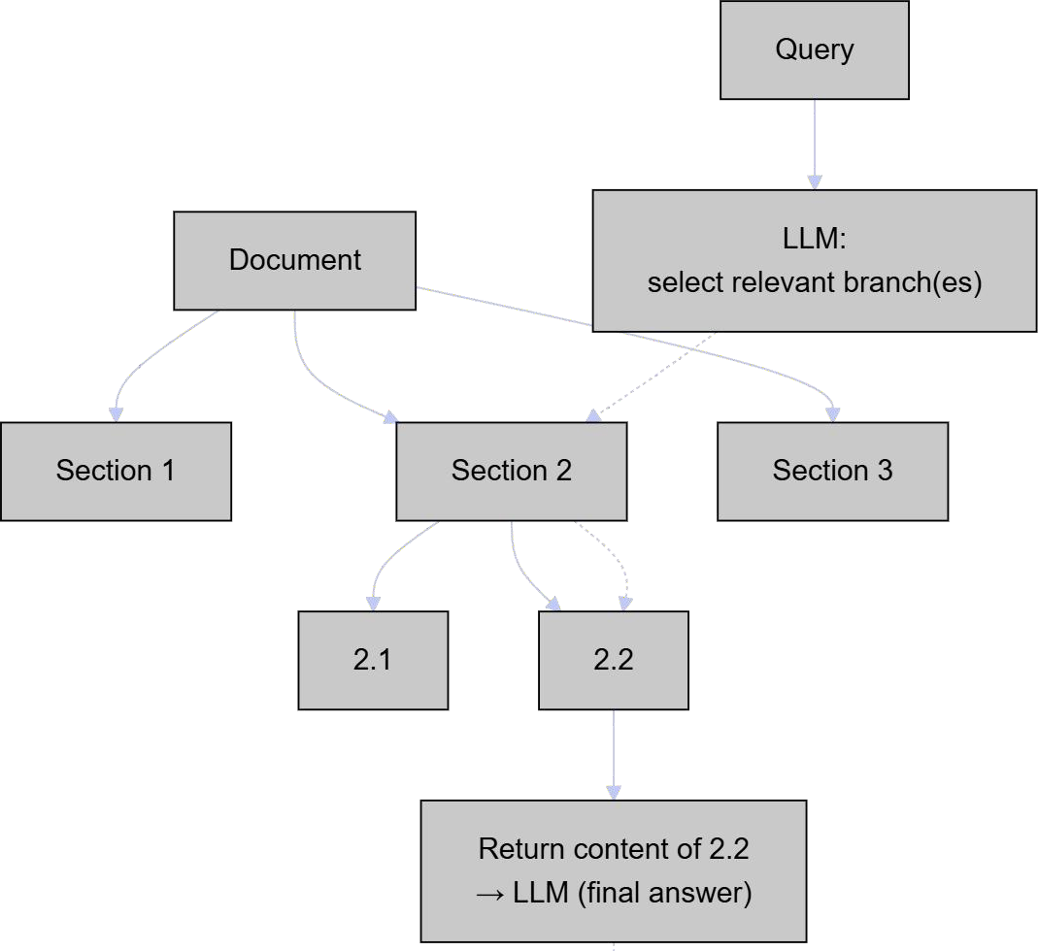
Figure 4. Vectorless Retrieval Pipeline

Graph RAG
Graph-based retrieval represents organizational knowledge as a graph of entities and the relationships between them, rather than as independent text chunks. Documents are processed to extract entities (people, organizations, projects, policies) and relationships between them, which are stored in a graph database; at query time, retrieval can traverse these relationships to assemble evidence that spans multiple documents or sections connected only through shared entities. This makes graph RAG particularly suited to multi-hop queries questions whose answer requires combining facts from two or more sources connected by a relationship not explicit in either source alone
Where vector and vectorless retrieval both operate on a document (or independently on each document in a corpus), graph RAG's distinguishing characteristic is that it can answer queries whose

evidence does not exist as a contiguous passage anywhere in the corpus, but only as the composition of several separate facts. This capability comes at the cost of a more complex ingestion pipeline entity extraction, relationship extraction, and graph construction must be performed and maintained as the underlying documents change and at query time, multi-hop traversal can require multiple LLM calls to determine which relationships to follow, increasing latency and token cost relative to single-step retrieval. Graph RAG is best suited to domains where relational structure is itself part of the knowledge being queried organizational hierarchies, compliance dependency webs, supply chains, or fraud/transaction networks rather than domains where each document is largely self-contained.
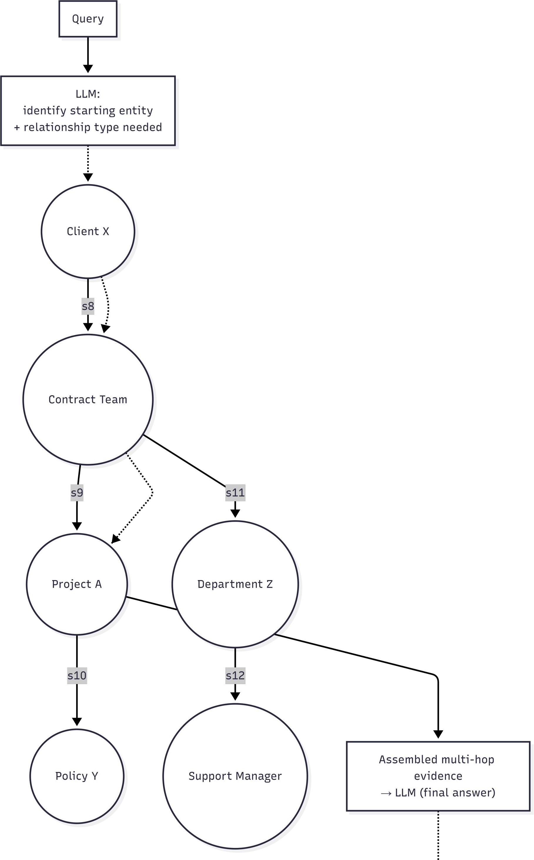
Figure 4. Graph Retrieval Pipeline

Retrieval effectiveness was measured using standard information retrieval metrics that assess how well a system can find and order relevant documents for a specific query [10]. These metrics are important because the quality of retrieval directly affects the information that the generation model has access to. Poor retrieval significantly limits the quality of generation, no matter how powerful the large language model is.

Summary
The three paradigms surveyed above differ along the same four axes: how knowledge is represented, what kind of query each is best suited to answer, what ingestion overhead each requires, and how retrieval is mechanically performed at query time. Table 3 summarizes these distinctions as a qualitative reference; Section VI tests these characterizations empirically against a common question set.

Dimension | Vector RAG | Vectorless Retrieval | Graph RAG
Knowledge representati on | Dense embedding s in a vector index | Hierarchica l tree mirroring document structure | Entity-relationship graph
Best-suited query type | Semantic / paraphrase d queries | Structured, single-document lookups | Multi-hop, relational queries
Ingestion overhead | Embedding generation  + vector index constructio n | Tree constructio n from existing document structure | Entity and relationship extraction + graph construction
Per-query mechanism | Nearest-neighbor search over embedding s | LLM-  driven tree navigation | Graph traversal across entities/relati onships
Table 1. Comparision
No single approach works best in all four areas at the same time: vector RAG is good at understanding general meanings, but it's not great at finding exact terms and needs continuous updates to its embeddings and indexes; vectorless retrieval is precise and uses less infrastructure, but it struggles with queries that need combining information from different parts; and graph RAG can handle complex, multi-step questions, but it requires a complicated setup and has slower query responses.
    - Survey of Empirical Comparisons

Sections II and III established that vector, vectorless, and graph-based retrieval represent distinct knowledge representations within an agentic harness, each hypothesized to suit a different class of query. Rather than constructing a new evaluation, we synthesize three recent empirical studies that each isolate one pairwise comparison between these paradigms under controlled conditions.

IV.A Vector RAG vs. Vectorless
A 2025 study by PricewaterhouseCoopers [15] is the first to compare vector-based agentic RAG with hierarchical node-based reasoning systems that navigate documents without using embeddings. The evaluation used 1,200 U.S. SEC filings (including 10-K, 10-Q, and 8-K forms) from Fortune 500 companies between 2020 and 2025, with each document averaging over 73,000 tokens. The vector system used 512-token chunks for hybrid search, while the vectorless system represented each
performance drops when dealing with medium or hard questions where the needed information isn't clearly found through similarity alone. However, GraphRAG-Bench [17] warns against assuming GraphRAG is always better.
It points to previous studies showing that GraphRAG actually has 13.4% lower accuracy than standard RAG on Natural Questions, and a 16.6% drop in accuracy for time-sensitive queries. So, the benefit of GraphRAG seems to depend on the data actually having the kind of relational structure that the graph traversal method is designed to use.

    - Survey Cost and Latency Formulation
The cost of an agentic RAG query is determined by the cumulative cost of all LLM calls involved in planning, retrieval, and answer generation. The total cost for query q is given by
n

document as a hierarchical node tree that matched its table of contents, similar to Section III.B. Medium. Across 65 multi-hop, 65 single-hop, and 20 summary
C_{q}= ∑

i=1
InputTokens_{i}R_{in}+OutputTokens_{i}R_{out}

questions, the vector-based RAG system had a 68% win rate compared to the hierarchical node-based system, with similar response times (5.2 seconds versus 5.98 seconds).
The vectorless system struggled in two specific areas: it couldn't answer two questions and gave two incorrect answers because of limitations in the context window. In contrast, the vector RAG system was able to retrieve relevant information for every question. The researchers believe this happens because the LLM's ability to select relevant sections from the table of contents wasn't as effective as the vector-based semantic matching.
The two methods also differ in initial costs: node-based processing costs $30.62 per 10-K filing for creating a hierarchical tree, while there's no equivalent vector-based cost beyond standard embedding. The authors suggest a hybrid approach as a future directionusing vector embeddings to reduce the number of candidate nodes before letting the LLM process them, which would help overcome the table-of-contents bottleneck while keeping structured reasoning intact.

IV.B Vector RAG vs. Graph RAG
A 2025 benchmark in the telecom field focused on Open RAN specifications [16] found that GraphRAG and Hybrid GraphRAG perform better than Vector RAG in tasks that require complex reasoning. Vector RAG works well for simple questions, achieving 0.61 accuracy, but its
Where n stands for the number of large
language model calls, and R_in and R_out represent the input and output token rates. The cost distribution varies depending on the approach used: vector RAG adds cost during the ingestion process, vectorless retrieval moves the cost to query time by using hierarchical traversal, and graph RAG depends on the number of relationship hops neede and the average across all queries is
1 N
AverageCost= ∑ C_{q}
N
q=1

The PwC study highlights this trade-off, showing a preprocessing cost of $30.62 per 10-K filing with GPT-4o, compared to $22.27 with GPT-
4.1 mini and $5.94 with Gemini 2.5 Flash.
These results show that choosing the right model has a big impact on overall cost, regardless of the retrieval method used. Latency is measured as the total time taken from start to finish for a query. Even though the retrieval methods differ, vector RAG and hierarchical retrieval had similar response times (5.2 seconds and 5.98 seconds, respectively). Therefore, cost and latency should be considered as separate factors and reported together with the quality of the answer, since a method can be costly but fast, or fast but expensive.
    - Discussion
The analysis in Section IV.C and the cost differences discussed in Section V suggest a shared conclusion: there isn't one retrieval method that

works best for every query. Using the wrong method doesn't just lead to less accurate answersit can also cause a mismatch between the cost and speed of the process. For instance, you might end up spending
improve.

    - Limitations and Conclusion

extra time on preprocessing that's unnecessary for a query that could have been handled well by a vector-based RAG system, or you might waste time on graph traversal when the query doesn't need any relational structure. This means we should go back to the agent harness described in Section II.A, but not treat it as a fixed system that only uses one retrieval method. Instead, it should act as a router that selects the best retrieval method based on the query itself.
A practical way to decide which method to use comes from the failure patterns we saw in Section IV. If a query is asking for a simple fact that can be expressed in different ways, it should go to vector retrieval, as shown in Section IV.A. If the query needs to follow relationships between entities, like approval chains or ownership structures, then graph retrieval is the right choice, as highlighted in Section
IV.B. For queries where the answer is in one specific part of a structured document and exact traceability is important for auditing, vectorless retrieval is the best fit.
However, Section IV.A also shows that selecting the right section to search can be error-prone, so it's better if the harness narrows down possible sections first, such as by doing a quick vector check of section titles, before handing the query to the LLM for processing this approach was suggested as future work in the PwC study.
The routing decision is made by the harness's planning step (Section II.A) before any retrieval takes place. This planning step's accuracy becomes a new factor in the failure attribution model from Section II.B: an incorrect routing choice is a type of planning failure (Pq=0, or a misclassification in the simpler version) that happens before and independently of the chosen retrieval method. Therefore, an agent-based RAG system can fail in a way that isn't covered by the three retrieval method comparisons in Section IV. This failure isn't because any one method was bad on its own, but because the harness sent the query to the wrong method.
For enterprise use, this changes how we think about the system's architecture. Instead of picking one retrieval method and using it across the whole system, organizations should plan to run all three methodsvector, vectorless, and graph RAG at the same time, all controlled by a single harness. The router itself becomes the most important and delicate part of the system, because, according to the failure attribution logic from Section II.B, any query that's sent to the wrong retrieval method is a failure that nothing can fix, even if the underlying methods
This paper looked at three different ways of retrieving information in agentic RAG systems, checked the tools and testing methods used with them, and brought together existing research comparisons instead of running new tests. This method has some clear drawbacks. First, the three studies reviewed in Section IV were done using different sets of text (SEC filings, ORAN telecom specs, and Natural Questions), with different models and tools. The way these tools were built (Section II.A) varies between studies, and we can't fully tell if these differences are causing the results we see, even though Section II.B was meant to help separate these factors. Second, no single study in our review compared all three retrieval methods at the same time using the same setup and text set; so our analysis in
IV.C is more like making educated guesses based on different studies rather than a fair comparison of all three. Third, the way we suggest routing information in Section VI is based on what went wrong in past studies, not on testing it as a complete system on its own. Despite these issues, the pattern that came up consistently across all the independent studies that each method struggles with queries that don't fit its type, and that the balance between cost and speed changes depending on the method supports the main idea of this paper: enterprise agentic RAG systems should use routing that combines several retrieval methods at the tool level, not stick to just one. Future research should do a proper three-way comparison using the same setup and text, and test routing accuracy on its own as a separate problem using the framework from Section II.B.

References

- M. Arslan, S. Munawar, and C. Cruz, "Sustainable Digitalization of Business with Multi-Agent RAG and LLM," Procedia Comput. Sci., vol. 246, pp. 4722–4731, 2024, doi: 10.1016/j.procs.2024.09.337.
- M. Arslan, S. Munawar, and C. Cruz, "Exploring Business Events using Multi-source RAG," Procedia Comput. Sci., vol. 246, pp. 4534–4540, 2024, doi: 10.1016/j.procs.2024.09.303.
- M. Sharma, S. Taneja, T. O. Olubiyi, B. P. Chahal, and S. Puri, "The Role of Large Language Model (LLM) in Automating Business Intelligence and Finance," in Advanced Interdisciplinary Applications of Large Language Models and AI Agents, S. Biju, Ed. IGI Global Scientific Publishing, 2026, pp. 31–50.
- Meilisearch. (2025, September 18). Modular RAG: What it is, how it works, architecture & more. Meilisearch Blog. Available at: Meilisearch Blog.
- Latif, S., Ameer, H., Akram, M.H. and Fatima, M., 2025, August. The Chunking Paradigm: Recursive Semantic for RAG Optimization. In Proceedings of the 8th International Conference on Natural Language and Speech Processing (ICNLSP-2025) (pp. 137-145).
- Wang, X., Wang, Z., Gao, X., Zhang, F., Wu, Y., Xu, Z., Shi,
T., Wang, Z., Li, S., Qian, Q. and Yin, R., 2024, November. Searching for best practices in retrieval-augmented generation. In Proceedings of the 2024 Conference on Empirical Methods in Natural Language Processing (pp. 17716-17736).
- Python Software Foundation. (2024). Python libraries for document processing: python-docx, PyPDF2, pdfplumber,

openpyxl.
- Explosion AI. (2024). spaCy: Industrial-strength Natural Language Processing. Advanced NLP library documentation.
- Wang, X., Wang, Z., Gao, X., Zhang, F., Wu, Y., Xu, Z., Shi,
T., Wang, Z., Li, S., Qian, Q. and Yin, R., 2024, November. Searching for best practices in retrieval-augmented generation. In Proceedings of the 2024 Conference on Empirical Methods in Natural Language Processing (pp. 17716-17736).
- Bruckhaus, T., 2024. Rag does not work for enterprises. arXiv preprint arXiv:2406.04369.
- Nihal, A., 2025. A comparative study of retrieval-augmented generation (RAG) and fine-tuned large language models in conversational AI.
- AWS Prescriptive Guidance. (2026). Choosing an AWS vector database for RAG use cases.
- ApX Machine Learning. (2026). RAG Latency Optimization
| Analysis & Reduction. Course Material.
- [14] Bhogawar (2025) "Agentic Voice AI in Enterprise Call Centers" was cited for cost analysis claims unrelated to the current paper's focus.
- Lumer, E., Melich, M., Zino, O., Kim, E., Dieter, S., Honaganahalli Basavaraju, P., Subbiah, V. K., Burke, J. A., and Hernandez, R., 2025. "Rethinking Retrieval: From Traditional Retrieval Augmented Generation to Agentic and Non-Vector Reasoning Systems in the Financial Domain for Large Language Models." arXiv preprint arXiv:2511.18177.
- "Benchmarking Vector, Graph and Hybrid Retrieval Augmented Generation (RAG) Pipelines for Open Radio Access Networks (ORAN)." arXiv preprint arXiv:2507.03608, 2025.
- "When to use Graphs in RAG: A Comprehensive Analysis for Graph Retrieval-Augmented Generation (GraphRAG-Bench)." arXiv preprint arXiv:2506.05690, 2026.
- Singh, S., Radhakrishnan, H., Pathak, S., Rao, P. P., Krishnamoorthy, B., Meghanathan, N., and Ichimura, N., 2025. "Agentic Retrieval-Augmented Generation: A Survey on Agentic RAG." arXiv preprint arXiv:2501.09136. (for Section II.A agent harness background)
- "A Survey on Evaluation of LLM-based Agents." arXiv preprint arXiv:2503.16416, 2025. (for Section II.A/II.B harness/scaffold disentanglement)
- "RAGCap-Bench: Benchmarking Capabilities of LLMs in Agentic RAG Systems." arXiv preprint arXiv:2510.13910, 2025. (for Section II.B capability decomposition)
- VectifyAI, 2024. "PageIndex: Document Index for Reasoning-Based RAG." GitHub repository, https://github.com/VectifyAI/PageIndex. (for Section III.B vectorless retrieval)

